Quick Start User Guide

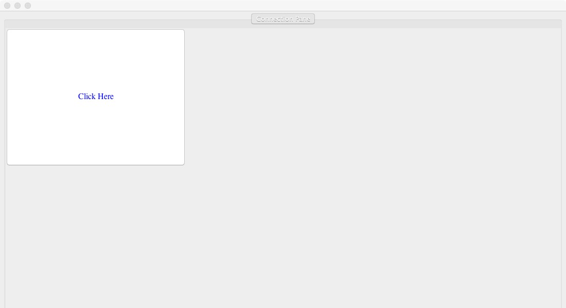

1.The first panel is to get enter the main GUI

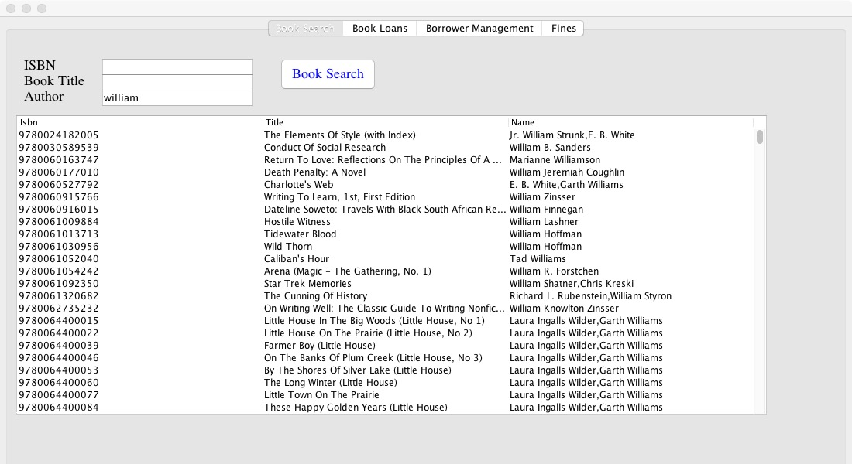

2.Enter either ISBN, Book, or Author, or both. It will appear all the books related.

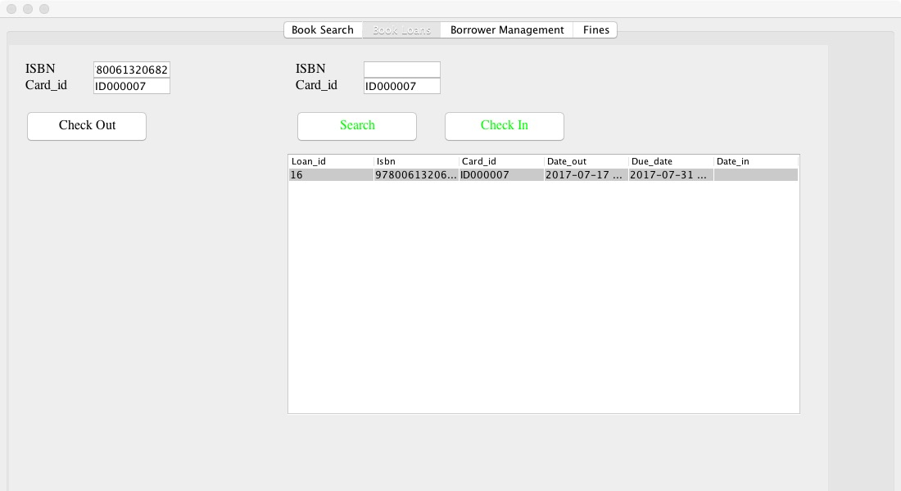

3. The left side helps you to check and the right side helps you check in. You need to enter the ISBN or Card id, click search then click on the book and check in.

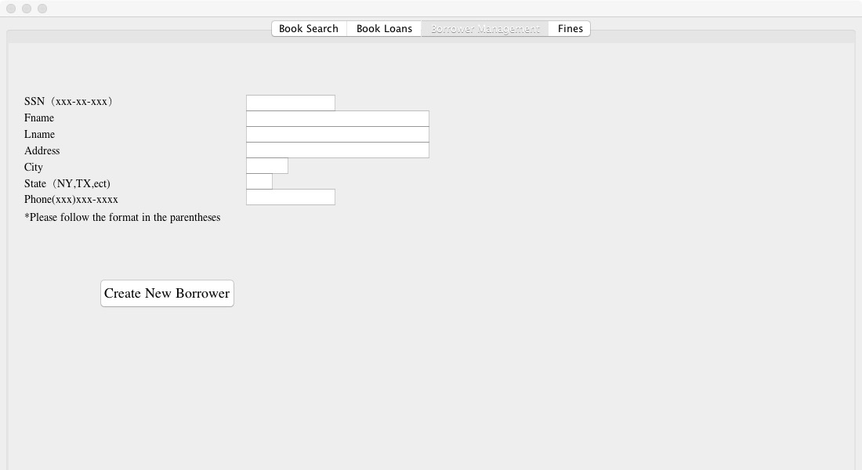

4.This is the panel for create new borrower, be notice the format.

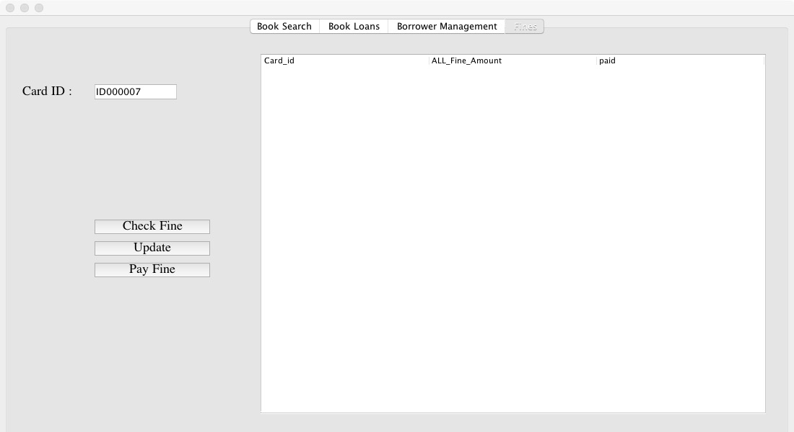

5. This is the fine panel, help you check, update and pay fines.